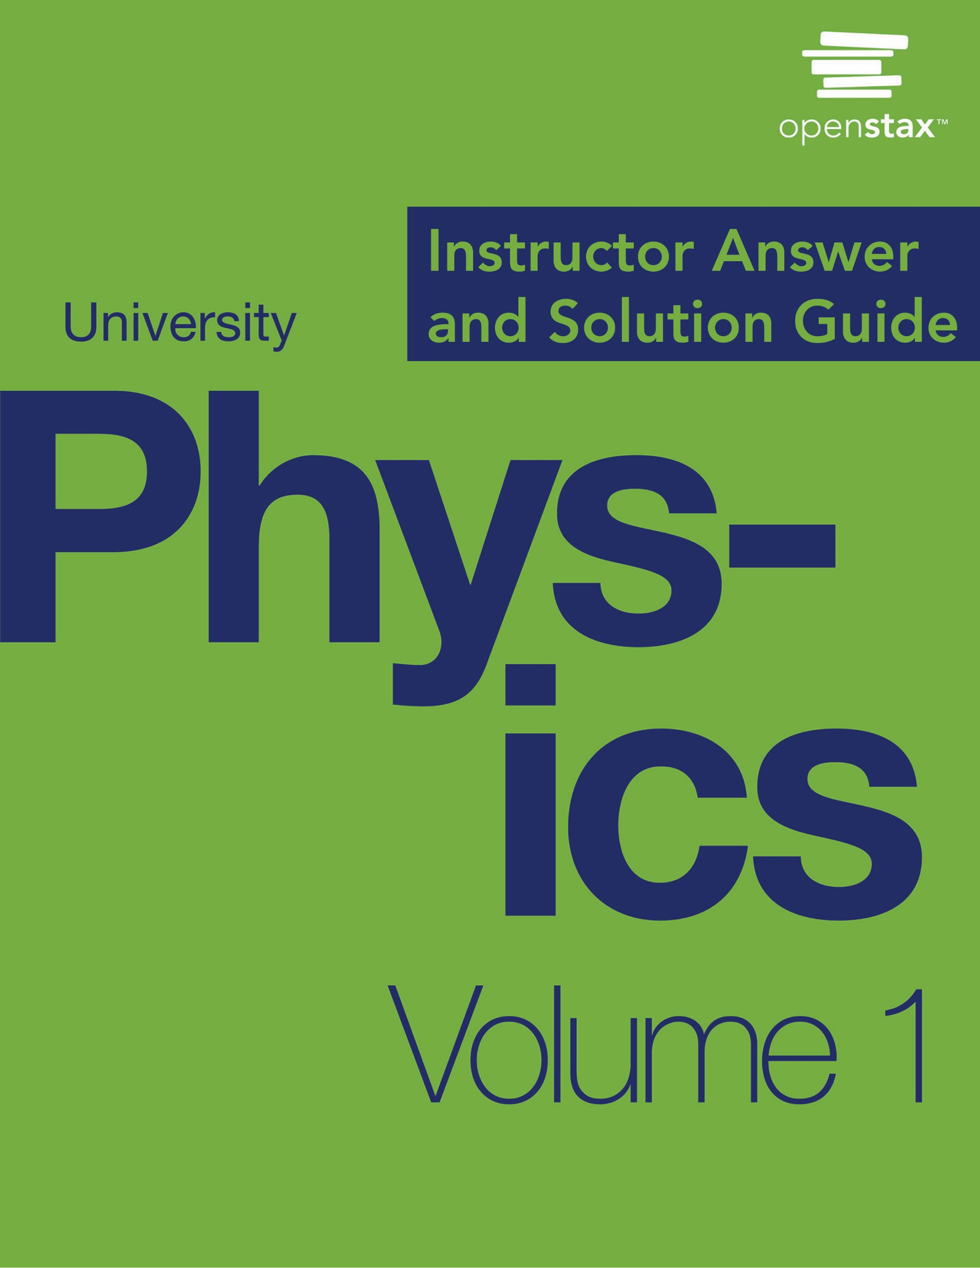

***University Physics Volume I***

**Unit 1: Mechanics**

**Chapter 1: Units and Measurement**

**Conceptual Questions**

1. What is physics?

Solution

Physics is the science concerned with describing the interactions of energy, matter, space, and time to uncover the fundamental mechanisms that underlie every phenomenon.

1. Some have described physics as a “search for simplicity.” Explain why this might be an appropriate description.

Solution

Physics searches for a small number of theories that explain all natural phenomena.

1. If two different theories describe experimental observations equally well, can one be said to be more valid than the other (assuming both use accepted rules of logic)?

Solution

No, neither of these two theories is more valid than the other. Experimentation is the ultimate decider. If experimental evidence does not suggest one theory over the other, then both are equally valid. A given physicist might prefer one theory over another on the grounds that one seems more simple, more natural, or more beautiful than the other, but that physicist would quickly acknowledge that he or she cannot say the other theory is invalid. Rather, he or she would be honest about the fact that more experimental evidence is needed to determine which theory is a better description of nature.

1. What determines the validity of a theory?

Solution

Repeated experimental tests of its implications by various groups of experimenters determines the validity of a theory.

1. Certain criteria must be satisfied if a measurement or observation is to be believed. Will the criteria necessarily be as strict for an expected result as for an unexpected result?

Solution

Probably not. As the saying goes, “Extraordinary claims require extraordinary evidence.”

1. Can the validity of a model be limited or must it be universally valid? How does this compare with the required validity of a theory or a law?

Solution

Models are meant to capture only some aspects of a physical system. A theory or law should describe all aspects of the physical systems within their domain of applicability.

1. Identify some advantages of metric units.

Solution

Conversions between units require factors of 10 only, which simplifies calculations. Also, the same basic units can be scaled up or down using metric prefixes to sizes appropriate for the problem at hand.

1. What are the SI base units of length, mass, and time?

Solution

The SI base unit of length is the meter (m). The SI base unit of mass is the kilogram (kg). The SI base unit of time is the second (s).

1. What is the difference between a base unit and a derived unit? (b) What is the difference between a base quantity and a derived quantity? (c) What is the difference between a base quantity and a base unit?

Solution

a. Base units are defined by a particular process of measuring a base quantity whereas derived units are defined as algebraic combinations of base units. b. A base quantity is chosen by convention and practical considerations. Derived quantities are expressed as algebraic combinations of base quantities. c. A base unit is a standard for expressing the measurement of a base quantity within a particular system of units. So, a measurement of a base quantity could be expressed in terms of a base unit in any system of units using the same base quantities. For example, length is a base quantity in both SI and the English system, but the meter is a base unit in the SI system only.

1. For each of the following scenarios, refer to the following figure and table to determine which metric prefix on the meter is most appropriate for each of the following scenarios. (a) You want to tabulate the mean distance from the Sun for each planet in the solar system. (b) You want to compare the sizes of some common viruses to design a mechanical filter capable of blocking the pathogenic ones. (c) You want to list the diameters of all the elements on the periodic table. (d) You want to list the distances to all the stars that have now received any radio broadcasts sent from Earth 10 years ago.

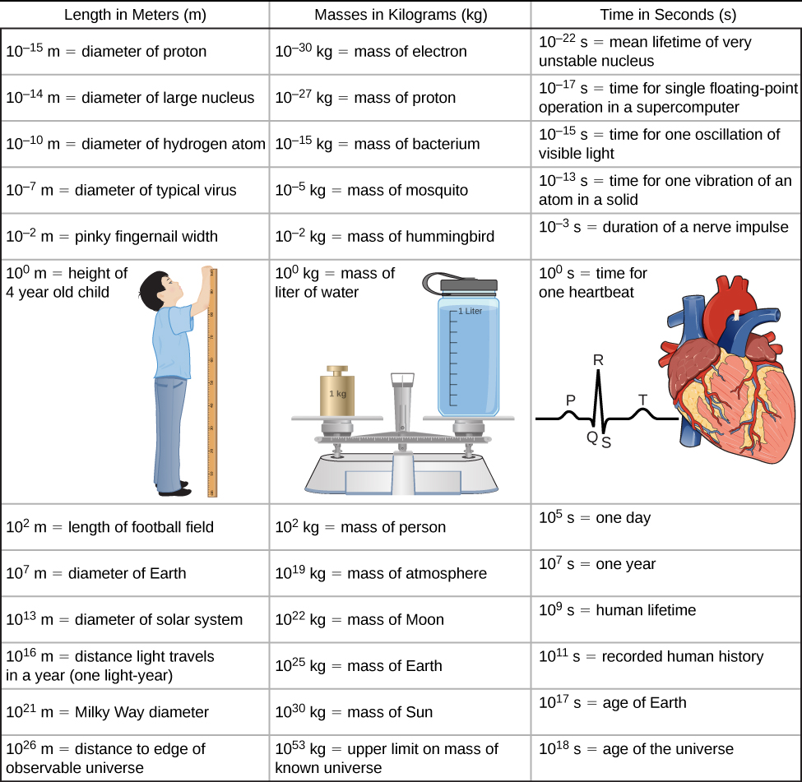

|  |  |  |  |  |  |
| --- | --- | --- | --- | --- | --- |
| **Prefix** | **Symbol** | **Meaning** | **Prefix** | **Symbol** | **Meaning** |
| yotta- | Y | 1024 | yocto- | y | 10–24 |
| zetta- | Z | 1021 | zepto- | z | 10–21 |
| exa- | E | 1018 | atto- | a | 10–18 |
| peta- | P | 1015 | femto- | f | 10–15 |
| tera- | T | 1012 | pico- | p | 10–12 |
| giga- | G | 109 | nano- | n | 10–9 |
| mega- | M | 106 | micro- |  | 10–6 |
| kilo- | k | 103 | milli- | m | 10–3 |
| hecto- | h | 102 | centi- | c | 10–2 |
| deka- | da | 101 | deci- | d | 10–1 |

Solution

Answers may vary. a. All planets are closer to the Sun than the solar system diameter, which is of the order 1013 m, so using terameters (1012 m) makes sense for this scenario.; b. Virus diameters are of the order 10–7 m, so either micrometers (10–6 m) or nanometers (10–9 m) make sense for this scenario.; c. All the atoms in the periodic table are at least as big as hydrogen, which has a diameter of order 10–10 m, so either nanometers (10–9 m) or picometers (10—12 m) make sense for this scenario.; d. The stars that have received our broadcasts from 10 years ago are within 10 light-years (of order 1017 m) of Earth. So, either petameters (1015 m) or exameters (1018 m) make sense for this scenario.

1. (a) What is the relationship between the precision and the uncertainty of a measurement? (b) What is the relationship between the accuracy and the discrepancy of a measurement?

Solution

a. Uncertainty is a quantitative measure of precision. b. Discrepancy is a quantitative measure of accuracy.

1. What information do you need to choose which equation or equations to use to solve a problem?

Solution

You need to know which physical quantities you were given (either explicitly or implicitly) and which physical quantities you need to find.

1. What should you do after obtaining a numerical answer when solving a problem?

Solution

Check to make sure it makes sense and assess its significance.

**Problems**

1. Find the order of magnitude of the following physical quantities.(a) The mass of Earth’s atmosphere:  kg; (b) The mass of the Moon’s atmosphere: 25,000 kg; (c) The mass of Earth’s hydrosphere:  kg; (d) The mass of Earth:  kg; (e) The mass of the Moon:  kg; (f) The Earth–Moon distance (semimajor axis):  m; (g) The mean Earth–Sun distance:  m; (h) The equatorial radius of Earth:  m; (i) The mass of an electron:  kg; (j) The mass of a proton:  kg; (k) The mass of the Sun:  kg.

Solution

a. 1019 kg; b. 104 kg; c. 1021 kg; d. 1025 kg; e. 1023 kg; f. 109 m; g. 1011 m; h. 107 m; i. 10–30 kg; j. 10–27 kg; k. 1030 kg

1. Use the orders of magnitude you found in the previous problem to answer the following questions to within an order of magnitude. (a)How many electrons would it take to equal the mass of a proton? (b)How many Earths would it take to equal the mass of the Sun? (c) How many Earth–Moon distances would it take to cover the distance from Earth to the Sun? (d) How many Moon atmospheres would it take to equal the mass of Earth’s atmosphere? (e) How many moons would it take to equal the mass of Earth? (f)How many protons would it take to equal the mass of the Sun?

Solution

a. 10–27/10–30 = 103; b. 1030/1025 = 105; c. 1011/109 = 102;d. 1019/104 = 1015;e. 1025/1023 = 102; f. 1030/10–27 = 1057

For the remaining questions, you need to use the following figure to obtain the necessary orders of magnitude of lengths, masses, and times.



1. Roughly how many heartbeats are there in a lifetime?

Solution

109 heartbeats

1. A generation is about one-third of a lifetime. Approximately how many generations have passed since the year 0?

Solution

102 generations

1. Roughly how many times longer than the mean life of an extremely unstable atomic nucleus is the lifetime of a human?

Solution

1031 times

1. Calculate the approximate number of atoms in a bacterium. Assume the average mass of an atom in the bacterium is 10 times the mass of a proton.

Solution

1011 atoms

1. (a) Calculate the number of cells in a hummingbird assuming the mass of an average cell is 10 times the mass of a bacterium. (b) Making the same assumption, how many cells are there in a human?

Solution

a. 1012 cells per hummingbird b. 1016 cells per person

1. Assuming one nerve impulse must end before another can begin, what is the maximum firing rate of a nerve in impulses per second?

Solution

103 nerve impulses/s

1. About how many floating-point operations can a supercomputer perform each year?

Solution

107/10–17 = 1024 floating-point operations/yr

1. Roughly how many floating-point operations can a supercomputer perform in a human lifetime?

Solution

109/10–17 = 1026 floating-point operations per human lifetime

1. The following times are given using metric prefixes on the base SI unit of time: the second. Rewrite them in scientific notation without the prefix. For example, 47 Ts would be rewritten as  s. (a) 980 Ps; (b) 980 fs; (c) 17 ns; (d) 

Solution

a. s; b. s; c. s; d. s

1. The following times are given in seconds. Use metric prefixes to rewrite them so the numerical value is greater than one but less than 1000. For example, s could be written as either 7.9 cs or 79 ms. (a) s; (b) 0.045 s; (c) s; (d)  s.

Solution

a. 957 ks; b. 4.5 cs or 45 ms; c. 550 ns; d. 31.6 Ms

1. The following lengths are given using metric prefixes on the base SI unit of length: the meter. Rewrite them in scientific notation without the prefix. For example, 4.2 Pm would be rewritten as  m. (a) 89 Tm; (b) 89 pm; (c) 711 mm; (d)

Solution

a.  m; b.  m; c.  m; d.  m

1. The following lengths are given in meters. Use metric prefixes to rewrite them so the numerical value is bigger than one but less than 1000. For example,  m could be written either as 7.9 cm or 79 mm. (a) m; (b) 0.0074 m; (c)  m; (d)  m.

Solution

a. 75.9 Mm; b. 7.4 mm; c. 88 pm; d. 16.3 Tm

1. The following masses are written using metric prefixes on the gram. Rewrite them in scientific notation in terms of the SI base unit of mass: the kilogram. For example, 40 Mg would be written as  kg. (a) 23 mg; (b) 320 Tg; (c) 42 ng; (d) 7 g; (e) 9 Pg.

Solution

a.  kg; b.  kg; c.  kg; d.  kg; e.  kg

1. The following masses are given in kilograms. Use metric prefixes on the gram to rewrite them so the numerical value is bigger than one but less than 1000. For example,  kg could be written as 70 cg or 700 mg. (a) kg; (b) kg; (c) kg; (d) kg; (e) kg.

Solution

a. 3.8 cg or 38 mg; b. 230 Eg; c. 24 ng; d. 8 Eg e. 4.2 g

1. The volume of Earth is on the order of 1021 m3. (a) What is this in cubic kilometers (km3)? (b) What is it in cubic miles (mi3)? (c) What is it in cubic centimeters (cm3)?

Solution

a. 1012 km3; b. 1011 mi3; c. 1027 cm3

1. The speed limit on some interstate highways is roughly 100 km/h. (a) What is this in meters per second? (b) How many miles per hour is this?

Solution

a. 27.8 m/s; b. 62 mi/h

1. A car is traveling at a speed of 33 m/s. (a) What is its speed in kilometers per hour? (b) Is it exceeding the 90 km/h speed limit?

Solution

a. ; b. At 120 km/h, the car is exceeding the speed limit.

1. In SI units, speeds are measured in meters per second (m/s). But, depending on where you live, you’re probably more comfortable of thinking of speeds in terms of either kilometers per hour (km/h) or miles per hour (mi/h). In this problem, you will see that 1 m/s is roughly 4 km/h or 2 mi/h, which is handy to use when developing your physical intuition. More precisely, show that (a) and (b).

Solution

a.  km/h; b.  mi/h

1. American football is played on a 100-yd-long field, excluding the end zones. How long is the field in meters? (Assume that 1 m = 3.281 ft.)

Solution

91.4 m

1. Soccer fields vary in size. A large soccer field is 115 m long and 85.0 m wide. What is its area in square feet? (Assume that 1 m = 3.281 ft.)

Solution



1. What is the height in meters of a person who is 6 ft 1.0 in. tall?

Solution

1.85 m

1. Mount Everest, at 29,028 ft, is the tallest mountain on Earth. What is its height in kilometers? (Assume that 1 m = 3.281 ft.)

Solution

8.847 km

1. The speed of sound is measured to be 342 m/s on a certain day. What is this measurement in kilometers per hour?

Solution



1. Tectonic plates are large segments of Earth’s crust that move slowly. Suppose one such plate has an average speed of 4.0 cm/yr. (a) What distance does it move in 1.0 s at this speed? (b) What is its speed in kilometers per million years?

Solution

a. ; b. 40 km/My

1. The average distance between Earth and the Sun is  m. (a) Calculate the average speed of Earth in its orbit (assumed to be circular) in meters per second. (b) What is this speed in miles per hour?

Solution

a. ; b. 

1. The density of nuclear matter is about 1018 kg/m3. Given that 1 mL is equal in volume to cm3, what is the density of nuclear matter in megagrams per microliter (that is,)?

Solution



1. The density of aluminum is 2.7 g/cm3. What is the density in kilograms per cubic meter?

Solution



1. A commonly used unit of mass in the English system is the pound-mass, abbreviated lbm, where 1 lbm = 0.454 kg. What is the density of water in pound-mass per cubic foot?

Solution

62.4 lbm/ft3

1. A furlong is 220 yd. A fortnight is 2 weeks. Convert a speed of one furlong per fortnight to millimeters per second.

Solution

0.166 mm/s

1. It takes  radians (rad) to get around a circle, which is the same as 360°. How many radians are in 1°?

Solution

0.017 rad

1. Light travels a distance of about  m/s. A light-minute is the distance light travels in 1 min. If the Sun is  m from Earth, how far away is it in light-minutes?

Solution

8 light-minutes

1. A light-nanosecond is the distance light travels in 1 ns. Convert 1 ft to light-nanoseconds.

Solution

1 light-nanosecond

1. An electron has a mass of  kg. A proton has a mass of  What is the mass of a proton in electron-masses?

Solution

 electron-masses

1. A fluid ounce is about 30 mL. What is the volume of a 12 fl-oz can of soda pop in cubic meters?

Solution

 m3

1. A student is trying to remember some formulas from geometry. In what follows, assume  is area,  is volume, and all other variables are lengths. Determine which formulas are dimensionally consistent. (a) ; (b) ; (c) ; (d) ; (e) .

Solution

a. This formula is dimensionally consistent; both terms have dimensions L3. b. This formula is dimensionally consistent; all three terms have dimensions L2. c. This formula is not dimensionally consistent. d. This formula is not dimensionally consistent. e. This formula is dimensionally consistent; both terms have dimensions L3.

1. Consider the physical quantities *s*, *v, a,* and *t* with dimensions , , , and . Determine whether each of the following equations is dimensionally consistent. (a) ; (b) ; (c) ; (d) .

Solution

a. Yes, both terms have dimension L2T-2 b. No. c. Yes, both terms have dimension LT-1 d. Yes, both terms have dimension LT-2

1. Consider the physical quantities , , , , and  with dimensions [*m*] = M, [*s*] = L, [*v*] = LT–1, [*a*] = LT–2, and [*t*] = T. Assuming each of the following equations is dimensionally consistent, find the dimension of the quantity on the left-hand side of the equation: (a) *F* = *ma*; (b) *K* = 0.5*mv*2; (c) *p* = *mv*; (d) *W* = *mas*; (e) *L = mvr*.

Solution

a. [F] = MLT–2; b. [K] = ML2T–2; c. [p] = MLT–1; d. [W] = ML2T–2; e. [L] = ML2T–1

1. Suppose quantity  is a length and quantity  is a time. Suppose the quantities  and  are defined by *v* = *ds*/*dt* and *a* = *dv*/*dt*. (a) What is the dimension of *v*? (b) What is the dimension of the quantity *a*? What are the dimensions of (c), (d) , and (e) *da*/*dt*?

Solution

a. [v] = LT–1; b. [a] = LT–2; c.  = L; d. LT–1; e. LT–3

1. Suppose [V] = L3, [] = ML–3, and [t] = T. (a) What is the dimension of ? (b) What is the dimension of *dV*/*dt*? (c) What is the dimension of 

Solution

a. M; b. L3T–1; c. MT–1

1. The arc length formula says the length  of arc subtended by angle  in a circle of radius  is given by the equation . What are the dimensions of (a) *s*, (b) *r*, and (c) ?

Solution

a. L; b. L; c. L0 = 1 (that is, it is dimensionless)

1. Assuming the human body is made primarily of water, estimate the volume of a person.

Solution

102 kg/(103 kg/m3) = 10–1 m3

1. Assuming the human body is primarily made of water, estimate the number of molecules in it. (Note that water has a molecular mass of 18 g/mol and there are roughly 1024 atoms in a mole.)

Solution

(102 kg/(10–2 kg/mol))(1024 atoms/mol) = 1028 atoms

1. Estimate the mass of air in a classroom.

Solution

Answers will vary; but, after estimating the length, width, and height of the room, multiply them to get volume and then multiply by 1 kg/m3 for the density of air.

1. Estimate the number of molecules that make up Earth, assuming an average molecular mass of 30 g/mol. (Note there are on the order of 1024 objects per mole.)

Solution

[1025 kg/(10–2 kg/mol)](1024 molecules/mol) = 1051 molecules

1. Estimate the surface area of a person.

Solution

100 m2

1. Roughly how many solar systems would it take to tile the disk of the Milky Way?

Solution

(1021 m/1013 m)2 = 1016 solar systems

1. (a) Estimate the density of the Moon. (b) Estimate the diameter of the Moon. (c) Given that the Moon subtends at an angle of about half a degree in the sky, estimate its distance from Earth.

Solution

a.  kg/m3, estimated by bounding (denser than water, less dense than the densest everyday materials); b. volume is  m3, so diameter is 106 m; c. using the arc length formula with angle (0.5)(0.017 rad) = 10–2 rad, we have (106 m)/10–2 = 108 m

1. The average density of the Sun is on the order 103 kg/m3. (a) Estimate the diameter of the Sun. (b) Given that the Sun subtends at an angle of about half a degree in the sky, estimate its distance from Earth.

Solution

a. Volume is 1030 kg/(103 kg/m3) = 1027 m3, so diameter is 109 m.; b. 109 m/10–2 = 1011 m

1. Estimate the mass of a virus.

Solution

(103 kg/m3)(10–7 m)3 = 10–18 kg

1. A floating-point operation is a single arithmetic operation such as addition, subtraction, multiplication, or division. (a) Estimate the maximum number of floating-point operations a human being could possibly perform in a lifetime. (b) How long would it take a supercomputer to perform that many floating-point operations?

Solution

a. A reasonable estimate might be one operation per second for a total of 109 in a lifetime.; b. about (109)(10–17 s) = 10–8 s, or about 10 ns

1. Consider the equation 4000/400 = 10.0. Assuming the number of significant figures in the answer is correct, what can you say about the number of significant figures in 4000 and 400?

Solution

The number 4000 must have either three or four significant figures; 400 must have three significant figures.

1. Suppose your bathroom scale reads your mass as 65 kg with a 3% uncertainty. What is the uncertainty in your mass (in kilograms)?

Solution

2 kg

1. A good-quality measuring tape can be off by 0.50 cm over a distance of 20 m. What is its percent uncertainty?

Solution

2.5 × 10–2%

1. An infant’s pulse rate is measured to be 130 ± 5 beats/min. What is the percent uncertainty in this measurement?

Solution

4%

1. (a) Suppose that a person has an average heart rate of 72.0 beats/min. How many beats does he or she have in 2.0 years? (b) In 2.00 years? (c) In 2.000 years?

Solution

a. 7.6 ×107 beats (limited by 2.0 years); b. 7.57 ×107 beats (limited by 2.00 years); c. 7.57 ×107 beats (limited by 72.0 beats/min)

1. A can contains 375 mL of soda. How much is left after 308 mL is removed?

Solution

67 mL

1. State how many significant figures are proper in the results of the following calculations: (a) ; (b) ; (c) 

Solution

a. 3 (limited by 98.2 and 1.01); b. 3 (limited by 18.7); c. 3 (limited by 1.60)

1. (a) How many significant figures are in the numbers 99 and 100.? (b) If the uncertainty in each number is 1, what is the percent uncertainty in each? (c) Which is a more meaningful way to express the accuracy of these two numbers: significant figures or percent uncertainties?

Solution

a. The number 99 has 2 significant figures; 100. has 3 significant figures. b. 1.00%; c. percent uncertainties

1. (a) If your speedometer has an uncertainty of 2.0 km/h at a speed of 90 km/h, what is the percent uncertainty? (b) If it has the same percent uncertainty when it reads 60 km/h, what is the range of speeds you could be going?

Solution

a. 2.2%; b. 59 to 61 km/h

1. (a) A person’s blood pressure is measured to be  What is its percent uncertainty? (b) Assuming the same percent uncertainty, what is the uncertainty in a blood pressure measurement of 80 mm Hg?

Solution

a. 2%; b. 1 mm Hg

1. A person measures his or her heart rate by counting the number of beats in 30 s. If 40 ± 1 beats are counted in 30.0 ± 0.5 s, what is the heart rate and its uncertainty in beats per minute?

Solution

The heart rate is 80 beats/min and its uncertainty is 3 beats/min, which would be written (80 ± 3) beats/min.

1. What is the area of a circle 3.102 cm in diameter?

Solution

7.557 cm2

1. Determine the number of significant figures in the following measurements: (a) 0.0009, (b) 15,450.0, (c) 6×103, (d) 87.990, and (e) 30.42.

Solution

a. 1; the zeros in this number are placeholders that indicate the decimal point; b. 6; here, the zeros indicate that a measurement was made to the 0.1 decimal point, so the zeros are significant; c. 1; the value 103 signifies the decimal place, not the number of measured values; d. 5; the final zero indicates a measurement was made to the 0.001 decimal point, so it is significant; e. 4; any zeros located in between significant figures in a number are also significant

1. Perform the following calculations and express your answer using the correct number of significant digits. (a) A woman has two bags weighing 13.5 lb and one bag with a weight of 10.2 lb. What is the total weight of the bags? (b) The force *F* on an object is equal to its mass *m* multiplied by its acceleration *a*. If a wagon with mass 55 kg accelerates at a rate of 0.0255 m/s2, what is the force on the wagon? (The unit of force is called the *newton* and it is expressed with the symbol N.)

Solution

a. 37.2 lb; because the number of bags is an exact value, it is not considered in the significant figures; b. 1.4 N; because the value 55 kg has only two significant figures, the final value must also contain two significant figures

**Additional Problems**

1. Consider the equation *y = mt +b*, where the dimension of *y* is length and the dimension of *t* is time, and *m* and *b* are constants. What are the dimensions and SI units of (a) *m* and (b) *b*?

Solution

a. [m] = LT–1 and SI units are meters per second (m/s); b. [b] = L and SI units are meters (m)

1. Consider the equation  where *s* is a length and *t* is a time. What are the dimensions and SI units of (a) , (b) , (c) , (d) , (e) , and (f) *c*?

Solution

a.  and units are meters (m); b.  and units are meters per second (m/s); c.  and units are meters per second squared (m/s2); d.  and units are meters per second cubed (m/s3); e.  and units are m/s4; f. and units are m/s5.

1. (a) A car speedometer has a 5% uncertainty. What is the range of possible speeds when it reads 90 km/h? (b) Convert this range to miles per hour. Note 1 km = 0.6214 mi.

Solution

a. 85 to 95 km/h; b. 53 to 59 mi/h

1. A marathon runner completes a 42.188-km course in 2 h, 30 min, and 12 s. There is an uncertainty of 25 m in the distance traveled and an uncertainty of 1 s in the elapsed time. (a) Calculate the percent uncertainty in the distance. (b) Calculate the percent uncertainty in the elapsed time. (c) What is the average speed in meters per second? (d) What is the uncertainty in the average speed?

Solution

a. 0.059%; b. 0.01%; c. 4.681 m/s; d. 0.07%, 0.003 m/s

1. The sides of a small rectangular box are measured to be 1.80 ± 0.1 cm, 2.05 ± 0.02 cm, and 3.1 ± 0.1 cm long. Calculate its volume and uncertainty in cubic centimeters.

Solution

11 cm3 with a 10% uncertainty or 11 ± 2 cm3 (so the range is 9 to 13 cm3)

1. When nonmetric units were used in the United Kingdom, a unit of mass called the pound-mass (lbm) was used, where 1 lbm = 0.4539 kg. (a) If there is an uncertainty of 0.0001 kg in the pound-mass unit, what is its percent uncertainty? (b) Based on that percent uncertainty, what mass in pound-mass has an uncertainty of 1 kg when converted to kilograms?

Solution

a. 0.02%; b. 1×104 lbm

1. The length and width of a rectangular room are measured to be 3.955 ± 0.005 m and 3.050 ± 0.005 m. Calculate the area of the room and its uncertainty in square meters.

Solution

Percent uncertainty is 0.3%, so the area with uncertainty is 12.06 ± 0.04 m2

1. A car engine moves a piston with a circular cross-section of 7.500 ± 0.002 cm in diameter a distance of 3.250 ± 0.001 cm to compress the gas in the cylinder. (a) By what amount is the gas decreased in volume in cubic centimeters? (b) Find the uncertainty in this volume.

Solution

a. 143.6 cm3; b. 0.1 cm3 or 0.084%

**Challenge Problems**

1. The first atomic bomb was detonated on July 16, 1945, at the Trinity test site about 200 mi south of Los Alamos. In 1947, the U.S. government declassified a film reel of the explosion. From this film reel, British physicist G. I. Taylor was able to determine the rate at which the radius of the fireball from the blast grew. Using dimensional analysis, he was then able to deduce the amount of energy released in the explosion, which was a closely guarded secret at the time. Because of this, Taylor did not publish his results until 1950. This problem challenges you to recreate this famous calculation. (a) Using keen physical insight developed from years of experience, Taylor decided the radius *r* of the fireball should depend only on time since the explosion, *t*, the density of the air,  and the energy of the initial explosion, *E*. Thus, he made the educated guess that  for some dimensionless constant *k* and some unknown exponents *a*, *b*, and *c*. Given that [E] = ML2T–2, determine the values of the exponents necessary to make this equation dimensionally consistent. (*Hint*: Notice the equation implies that  and that .) (b) By analyzing data from high-energy conventional explosives, Taylor found the formula he derived seemed to be valid as long as the constant *k* had the value 1.03. From the film reel, he was able to determine many values of *r* and the corresponding values of *t*. For example, he found that after 25.0 ms, the fireball had a radius of 130.0 m. Use these values, along with an average air density of 1.25 kg/m3, to calculate the initial energy release of the Trinity detonation in joules (J). (*Hint*: To get energy in joules, you need to make sure all the numbers you substitute in are expressed in terms of SI base units.) (c) The energy released in large explosions is often cited in units of “tons of TNT” (abbreviated “t TNT”), where 1 t TNT is about 4.2 GJ. Convert your answer to (b) into kilotons of TNT (that is, kt TNT). Compare your answer with the quick-and-dirty estimate of 10 kt TNT made by physicist Enrico Fermi shortly after witnessing the explosion from what was thought to be a safe distance. (Reportedly, Fermi made his estimate by dropping some shredded bits of paper right before the remnants of the shock wave hit him and looked to see how far they were carried by it.)

Solution

a. a = 1/5, b = –1/5; and c = 2/5; so, ; b. J; c. 15 kt TNT, so Fermi’s estimate was well within a factor of 2 of the more accurate calculation done here

1. The purpose of this problem is to show the entire concept of dimensional consistency can be summarized by the old saying “You can’t add apples and oranges.” If you have studied power series expansions in a calculus course, you know the standard mathematical functions such as trigonometric functions, logarithms, and exponential functions can be expressed as infinite sums of the form  where the  are dimensionless constants for all  and *x* is the argument of the function. (If you have not studied power series in calculus yet, just trust us.) Use this fact to explain why the requirement that all terms in an equation have the same dimensions is sufficient as a definition of dimensional consistency. That is, it actually implies the arguments of standard mathematical functions must be dimensionless, so it is not really necessary to make this latter condition a separate requirement of the definition of dimensional consistency as we have done in this section.

Solution

Since each term in the power series involves the argument raised to a different power, the only way that every term in the power series can have the same dimension is if the argument is dimensionless. To see this explicitly, suppose [x] = LaMbTc. Then, [xn] = [x]n = LanMbnTcn. If we want [x] = [xn], then an = a, bn = b, and cn = c for all n. The only way this can happen is if a = b = c = 0.

This file is copyright 2016, Rice University. All Rights Reserved.